Functional Model
TicketEase: Smart Traffic Ticket Assistance
By
Priyanka Vankayalapati

1. Use Case Diagram
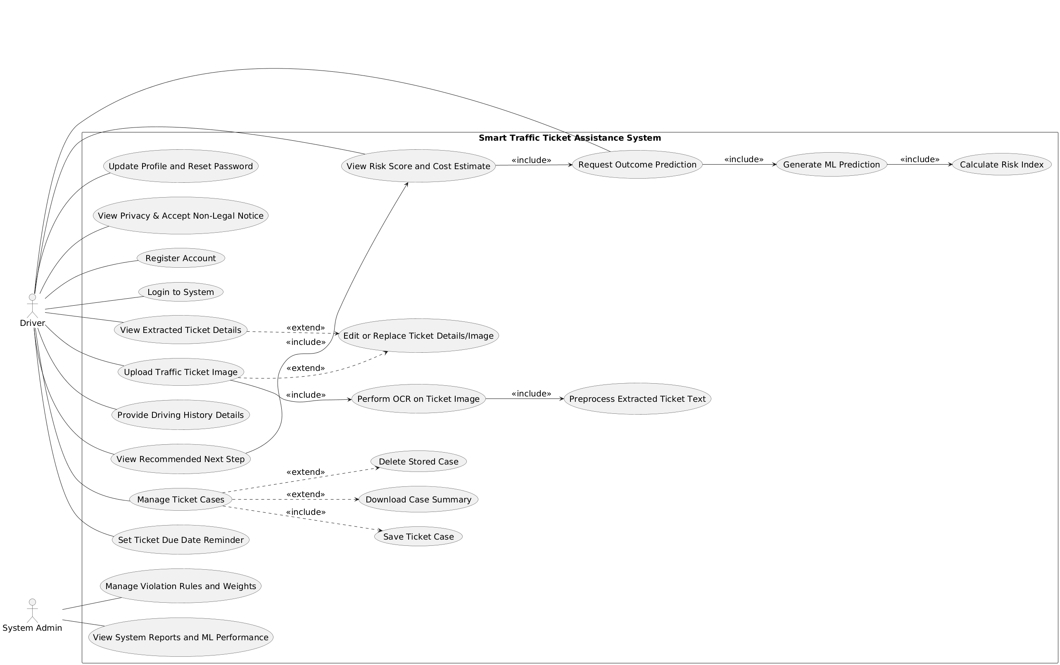
Figure.1 Use Case Diagram

2. Use Case Description

Use Case 1
Field | Details
Use Case Name | Register Account
ID | 1
Importance Level | High
Primary Actor | Driver
Use Case Type | Primary
Stakeholders and Interests | Driver wants account access; System owner wants registered users
Brief Description | Driver creates a new account to access the system
Trigger Type | External
Relationships | Association: Driver; Include: None; Extend: None; Generalization: None
Normal Flow of Events | 1. Driver opens site 2. System shows form 3. Driver enters details 4. System validates input 5. System creates account 6. System confirms registration
SubFlows | S-1: Validate required registration fields
Alternate/Exceptional Flows | A1: Email exists; system shows error A2: Missing fields; system prompts user A3: System unavailable; retry later
Linked Functional Requirements | 1

Use Case 2
Field | Details
Use Case Name | Login to System
ID | 2
Importance Level | High
Primary Actor | Driver
Use Case Type | Primary
Stakeholders and Interests | Driver wants secure access; Organization wants protected accounts
Brief Description | Driver logs into the system
Trigger Type | External
Relationships | Association: Driver; Include: None; Extend: None; Generalization: None
Normal Flow of Events | 1. Driver opens login page 2. Driver enters credentials 3. System validates 4. System grants access
SubFlows | S-1: Validate login credentials
Alternate/Exceptional Flows | A1: Invalid login; system shows error A2: Account locked; reset requested A3: Network issue; retry later
Linked Functional Requirements | 2

Use Case 3
Field | Details
Use Case Name | Upload Traffic Ticket Image
ID | 3
Importance Level | High
Primary Actor | Driver
Use Case Type | Primary
Stakeholders and Interests | Driver wants analysis; System wants valid image input
Brief Description | Driver uploads a ticket image for processing
Trigger Type | External
Relationships | Association: Driver; Include: Perform OCR on Ticket Image; Extend: Edit or Replace Ticket Details or Image; Generalization: None
Normal Flow of Events | 1. Driver selects image 2. System uploads file 3. System stores image 4. System forwards image for OCR
SubFlows | S-1: Validate image format
Alternate/Exceptional Flows | A1: Invalid format; system requests new file A2: Upload fails; retry A3: Image unclear; replace image
Linked Functional Requirements | 4

Use Case 4
Field | Details
Use Case Name | View Extracted Ticket Details
ID | 4
Importance Level | High
Primary Actor | Driver
Use Case Type | Primary
Stakeholders and Interests | Driver wants correct details; System wants verified data
Brief Description | Driver views ticket details extracted by the system
Trigger Type | External
Relationships | Association: Driver; Include: None; Extend: Edit or Replace Ticket Details or Image; Generalization: None
Normal Flow of Events | 1. System shows violation 2. System shows location 3. System shows fine 4. Driver reviews details
SubFlows | S-1: Load extracted fields
Alternate/Exceptional Flows | A1: Missing text; system flags fields A2: Incorrect text; driver edits
Linked Functional Requirements | 7

Use Case 5
Field | Details
Use Case Name | Provide Driving History Details
ID | 5
Importance Level | Medium
Primary Actor | Driver
Use Case Type | Primary
Stakeholders and Interests | Driver wants accurate results; System wants history input
Brief Description | Driver enters basic driving history
Trigger Type | External
Relationships | Association: Driver; Include: None; Extend: None; Generalization: None
Normal Flow of Events | 1. Driver enters history 2. Driver submits data 3. System stores details
SubFlows | S-1: Validate history input
Alternate/Exceptional Flows | A1: Missing input; system prompts user A2: Invalid input; correction requested
Linked Functional Requirements | 8

Use Case 6
Field | Details
Use Case Name | Request Outcome Prediction
ID | 6
Importance Level | High
Primary Actor | Driver
Use Case Type | Primary
Stakeholders and Interests | Driver wants decision guidance; System wants valid input
Brief Description | Driver requests prediction on whether to contest the ticket
Trigger Type | External
Relationships | Association: Driver; Include: Generate ML Prediction, Calculate Risk Index; Extend: None; Generalization: None
Normal Flow of Events | 1. Driver requests prediction 2. System validates inputs 3. System prepares features 4. System runs prediction 5. System prepares results
SubFlows | S-1: Validate ticket and history data
Alternate/Exceptional Flows | A1: Missing data; system requests completion A2: ML service unavailable; retry later
Linked Functional Requirements | 9, 10, 11, 12

Use Case 7
Field | Details
Use Case Name | View Risk Score and Cost Estimate
ID | 7
Importance Level | High
Primary Actor | Driver
Use Case Type | Primary
Stakeholders and Interests | Driver wants cost and risk clarity; System wants clear display
Brief Description | Driver views predicted chance score and long-term cost
Trigger Type | External
Relationships | Association: Driver; Include: None; Extend: None; Generalization: None
Normal Flow of Events | 1. System displays chance score 2. System displays cost estimate 3. System labels guidance 4. Driver reviews results
SubFlows | S-1: Load prediction results
Alternate/Exceptional Flows | A1: Results missing; system requests new prediction
Linked Functional Requirements | 13, 14, 15

Use Case 8
Field | Details
Use Case Name | View Recommended Next Step
ID | 8
Importance Level | Medium
Primary Actor | Driver
Use Case Type | Primary
Stakeholders and Interests | Driver wants action guidance; System wants clear explanation
Brief Description | Driver views suggested action and explanation
Trigger Type | External
Relationships | Association: Driver; Include: None; Extend: None; Generalization: None
Normal Flow of Events | 1. System displays suggestion 2. System displays explanation 3. Driver reviews guidance
SubFlows | S-1: Load recommendation message
Alternate/Exceptional Flows | A1: Suggestion unavailable; request new prediction
Linked Functional Requirements | 16, 17

Use Case 9
Field | Details
Use Case Name | Manage Ticket Cases
ID | 9
Importance Level | Medium
Primary Actor | Driver
Use Case Type | Primary
Stakeholders and Interests | Driver wants case management; System wants data integrity
Brief Description | Driver manages saved ticket cases
Trigger Type | External
Relationships | Association: Driver; Include: Save Ticket Case; Extend: Download Case Summary, Delete Stored Case; Generalization: None
Normal Flow of Events | 1. System shows case list 2. Driver selects case 3. Driver performs action 4. System updates list
SubFlows | S-1: Load saved cases
Alternate/Exceptional Flows | A1: No cases found; show empty list
Linked Functional Requirements | 20, 21, 22, 23

Use Case 10
Field | Details
Use Case Name | Set Ticket Due Date Reminder
ID | 10
Importance Level | Medium
Primary Actor | Driver
Use Case Type | Primary
Stakeholders and Interests | Driver wants reminders; System wants correct dates
Brief Description | Driver sets a reminder for ticket due date
Trigger Type | External
Relationships | Association: Driver; Include: None; Extend: None; Generalization: None
Normal Flow of Events | 1. Driver enters due date 2. Driver confirms reminder 3. System schedules reminder
SubFlows | S-1: Validate due date
Alternate/Exceptional Flows | A1: Invalid date; request correction
Linked Functional Requirements | 26, 27

Use Case 11
Field | Details
Use Case Name | Update Profile and Reset Password
ID | 11
Importance Level | Medium
Primary Actor | Driver
Use Case Type | Primary
Stakeholders and Interests | Driver wants account control; System wants secure data
Brief Description | Driver updates profile details and resets password
Trigger Type | External
Relationships | Association: Driver; Include: None; Extend: None; Generalization: None
Normal Flow of Events | 1. Driver edits profile 2. Driver requests password reset 3. System validates changes 4. System updates account
SubFlows | S-1: Validate profile fields
Alternate/Exceptional Flows | A1: Invalid input; request correction
Linked Functional Requirements | 28, 29

Use Case 12
Field | Details
Use Case Name | View Privacy and Accept Non Legal Notice
ID | 12
Importance Level | Medium
Primary Actor | Driver
Use Case Type | Primary
Stakeholders and Interests | Driver wants transparency; Organization wants compliance
Brief Description | Driver views privacy notice and accepts guidance disclaimer
Trigger Type | External
Relationships | Association: Driver; Include: None; Extend: None; Generalization: None
Normal Flow of Events | 1. System shows privacy notice 2. System shows disclaimer 3. Driver reviews notices 4. Driver accepts notices
SubFlows | S-1: Load policy content
Alternate/Exceptional Flows | A1: Driver declines notice; restrict access
Linked Functional Requirements | 33, 34

Use Case 13
Field | Details
Use Case Name | Perform OCR on Ticket Image
ID | 13
Importance Level | Medium
Primary Actor | System
Use Case Type | Included
Stakeholders and Interests | Driver wants accurate text; System wants readable image
Brief Description | System extracts text from ticket image
Trigger Type | Internal
Relationships | Association: Driver; Include: Preprocess Extracted Ticket Text; Extend: None; Generalization: None
Normal Flow of Events | 1. System reads image 2. System extracts text 3. System stores text
SubFlows | S-1: Validate image quality
Alternate/Exceptional Flows | A1: OCR fails; request new image
Linked Functional Requirements | 5

Use Case 14
Field | Details
Use Case Name | Preprocess Extracted Ticket Text
ID | 14
Importance Level | Medium
Primary Actor | System
Use Case Type | Included
Stakeholders and Interests | Driver wants clean data; System wants structured fields
Brief Description | System cleans and structures extracted text
Trigger Type | Internal
Relationships | Association: System; Include: None; Extend: None; Generalization: None
Normal Flow of Events | 1. System cleans text 2. System structures fields 3. System prepares features
SubFlows | S-1: Normalize extracted fields
Alternate/Exceptional Flows | A1: Text format error; flag for review
Linked Functional Requirements | 6, 11

Use Case 15
Field | Details
Use Case Name | Generate ML Prediction
ID | 15
Importance Level | Medium
Primary Actor | System
Use Case Type | Included
Stakeholders and Interests | Driver wants prediction; System wants valid features
Brief Description | System generates prediction using ML model
Trigger Type | Internal
Relationships | Association: Driver; Include: None; Extend: None; Generalization: None
Normal Flow of Events | 1. System loads features 2. System runs model 3. System stores result
SubFlows | S-1: Validate feature set
Alternate/Exceptional Flows | A1: Model error; retry prediction
Linked Functional Requirements | 10

Use Case 16
Field | Details
Use Case Name | Calculate Risk Index
ID | 16
Importance Level | Medium
Primary Actor | System
Use Case Type | Included
Stakeholders and Interests | Driver wants risk score; System wants valid parameters
Brief Description | System calculates risk index using formula
Trigger Type | Internal
Relationships | Association: System; Include: None; Extend: None; Generalization: None
Normal Flow of Events | 1. System loads weights 2. System applies formula 3. System stores risk score
SubFlows | S-1: Validate calculation inputs
Alternate/Exceptional Flows | A1: Missing values; request admin update
Linked Functional Requirements | 12

Use Case 17
Field | Details
Use Case Name | Edit or Replace Ticket Details or Image
ID | 17
Importance Level | Medium
Primary Actor | Driver
Use Case Type | Extended
Stakeholders and Interests | Driver wants correct data; System wants valid inputs
Brief Description | Driver edits ticket details or replaces image
Trigger Type | External
Relationships | Association: Driver; Include: None; Extend: Upload Traffic Ticket Image, View Extracted Ticket Details; Generalization: None
Normal Flow of Events | 1. Driver edits details 2. Driver replaces image 3. System validates updates 4. System saves changes
SubFlows | S-1: Validate updated data
Alternate/Exceptional Flows | A1: Invalid input; request correction
Linked Functional Requirements | 18, 19

Use Case 18
Field | Details
Use Case Name | Save Ticket Case
ID | 18
Importance Level | Medium
Primary Actor | Driver
Use Case Type | Included
Stakeholders and Interests | Driver wants saved case; System wants stored data
Brief Description | Driver saves ticket case
Trigger Type | External
Relationships | Association: Driver; Include: None; Extend: None; Generalization: None
Normal Flow of Events | 1. Driver selects save 2. System stores case 3. System confirms save
SubFlows | S-1: Validate case completeness
Alternate/Exceptional Flows | A1: Storage error; show message
Linked Functional Requirements | 20

Use Case 19
Field | Details
Use Case Name | Download Case Summary
ID | 19
Importance Level | Low
Primary Actor | Driver
Use Case Type | Extended
Stakeholders and Interests | Driver wants record; System wants controlled access
Brief Description | Driver downloads case summary
Trigger Type | External
Relationships | Association: Driver; Include: None; Extend: Manage Ticket Cases; Generalization: None
Normal Flow of Events | 1. System generates summary 2. System provides file 3. Driver downloads
SubFlows | S-1: Prepare summary file
Alternate/Exceptional Flows | A1: File error; retry later
Linked Functional Requirements | 22

Use Case 20
Field | Details
Use Case Name | Delete Stored Case
ID | 20
Importance Level | Low
Primary Actor | Driver
Use Case Type | Extended
Stakeholders and Interests | Driver wants remove case; System wants data integrity
Brief Description | Driver deletes stored ticket case
Trigger Type | External
Relationships | Association: Driver; Include: None; Extend: Manage Ticket Cases; Generalization: None
Normal Flow of Events | 1. Driver confirms delete 2. System removes case 3. System updates list
SubFlows | S-1: Confirm delete action
Alternate/Exceptional Flows | A1: Delete fails; show message
Linked Functional Requirements | 23

Use Case 21
Field | Details
Use Case Name | Manage Violation Rules and Weights
ID | 21
Importance Level | High
Primary Actor | System Admin
Use Case Type | Primary
Stakeholders and Interests | Admin wants rule control; System wants updated weights
Brief Description | Admin updates violation types and penalty weights
Trigger Type | External
Relationships | Association: System Admin; Include: None; Extend: None; Generalization: None
Normal Flow of Events | 1. Admin views rules 2. Admin edits values 3. System validates 4. System saves updates
SubFlows | S-1: Validate updated values
Alternate/Exceptional Flows | A1: Invalid values; request correction
Linked Functional Requirements | 39, 40

Use Case 22
Field | Details
Use Case Name | View System Reports and ML Performance
ID | 22
Importance Level | High
Primary Actor | System Admin
Use Case Type | Primary
Stakeholders and Interests | Admin wants system insight; Organization wants monitoring
Brief Description | Admin views reports and ML performance
Trigger Type | External
Relationships | Association: System Admin; Include: None; Extend: None; Generalization: None
Normal Flow of Events | 1. System shows case counts 2. System shows OCR logs 3. System shows ML logs 4. Admin generates report 5. Admin exports data
SubFlows | S-1: Load report data
Alternate/Exceptional Flows | A1: Report error; retry later
Linked Functional Requirements | 35, 36, 37, 41, 42

3. Activity Diagram
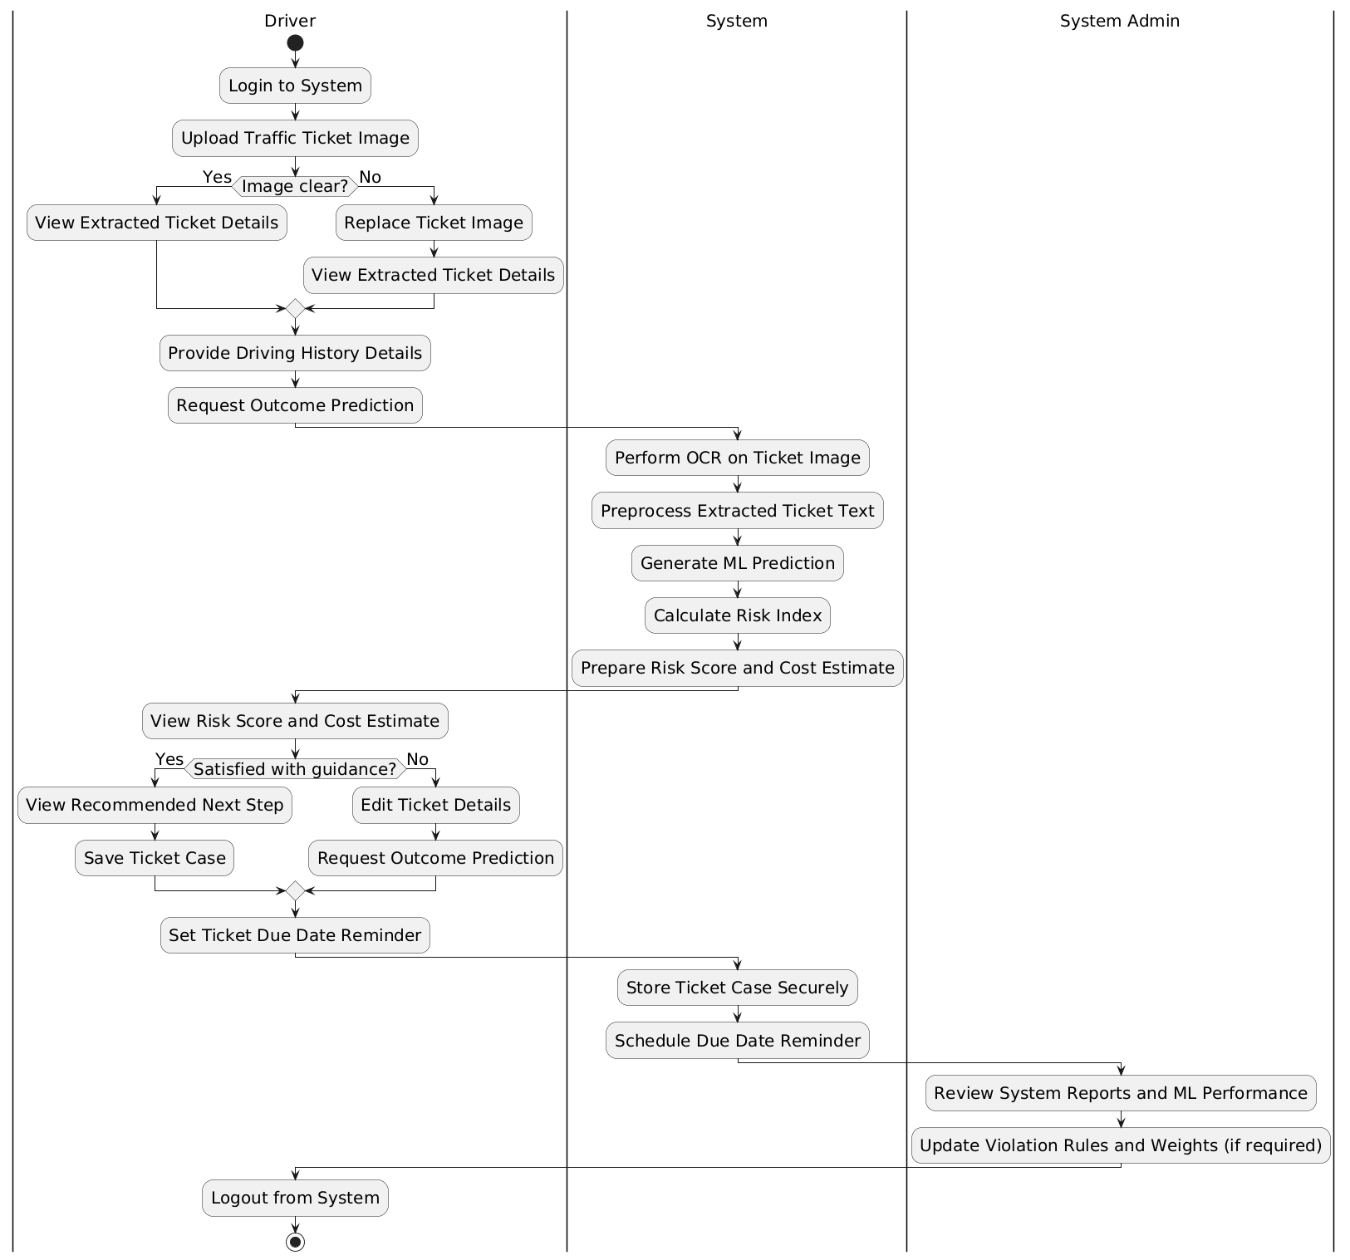
Figure.2 Activity Diagram

